SBStrapTM
Installation & User's Guide (1.7v)

Using SBStrapTM to carry your Snowboard

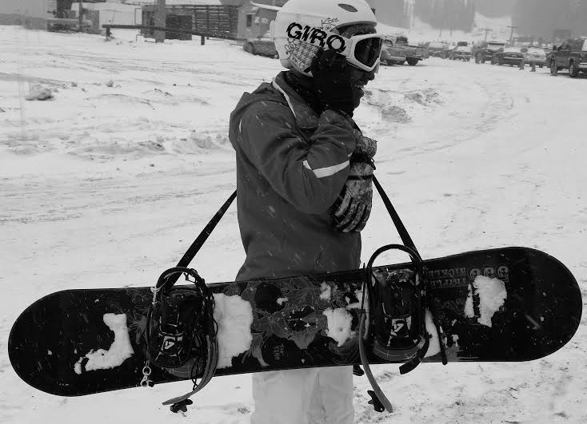

SBStrapTM Parts
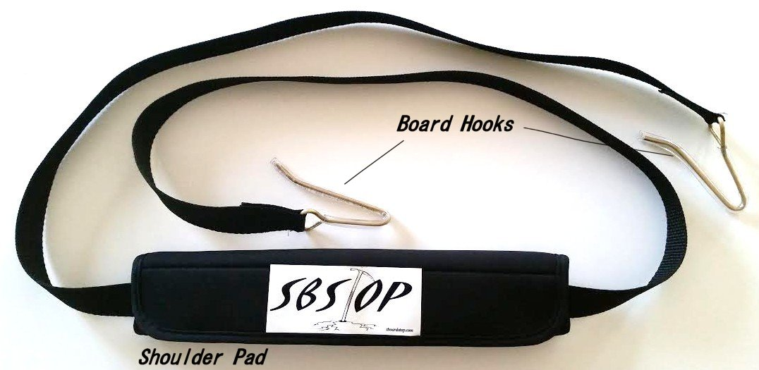

Install the SBStrap
- Place one hook edge on the edge of the snowboard in front of the boot binding.
- The SBStrap should run along the top side of the snowboard
- Then place the other hook edge on the edge of the snowboard in back of the other boot binding.
- The SBStrap should run along the top side of the snowboard
- The loop end of the SBStrap should be worn on the shoulder opposite the snowboard and the bottom of the board should rest against your leg or hip.

